**Circuit Diagram & Truth Table:**

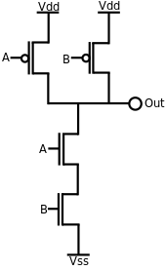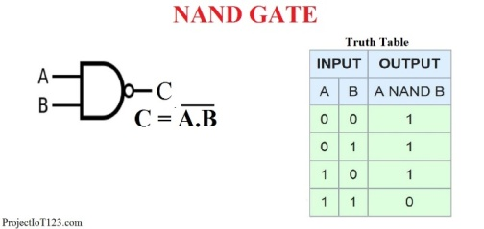

**Code:**

* **Design Module**

module nandgate(out,a,b);

input a,b;

output out;

wire x;

supply1 vdd;

supply0 gnd;

pmos p1(out,vdd,a);

pmos p2(out,vdd,b);

nmos n1(x,gnd,a);

nmos n1(out,x,b);

endmodule

* **TestBench**

module Baig;

reg a,b;

wire out;

nandgate ng(out,a,b);

initial

begin

a=1'b0;b=1'b0;

#10

a=1'b0;b=1'b1;

#10

a=1'b1;b=1'b0;

#10

a=1'b1;b=1'b1;

#10

$finish;

end

endmodule

**Output:**

